Part 1

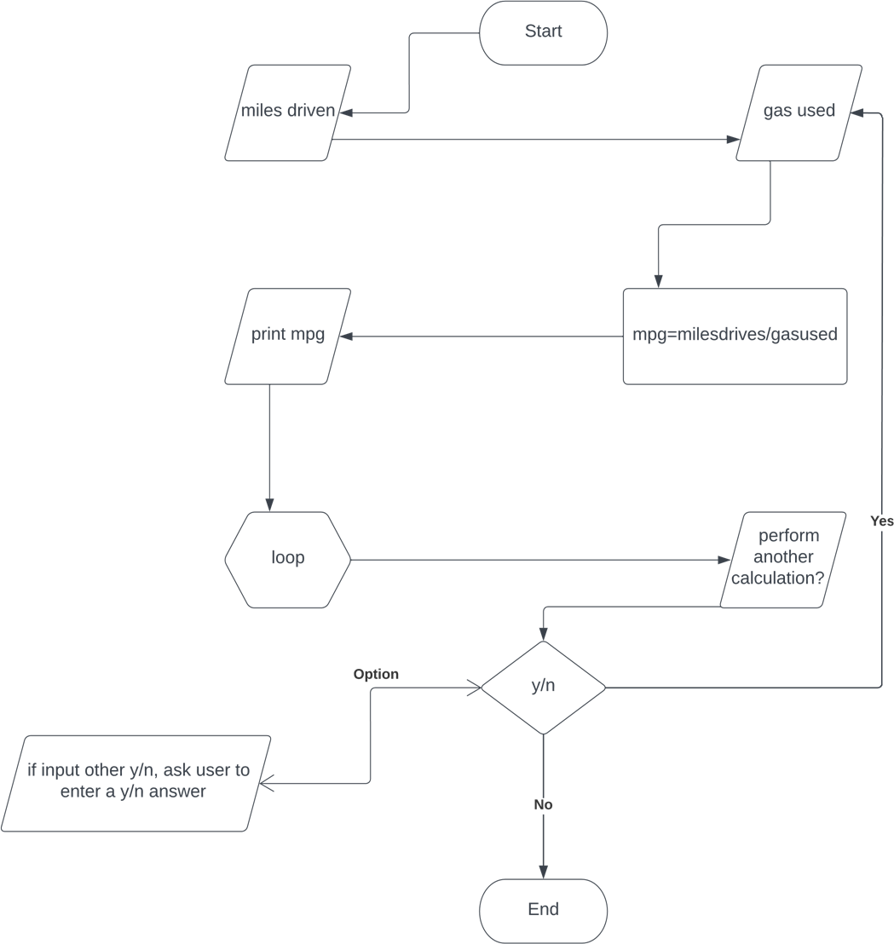

Part 2

while True:

#user input

miles driven = int(input("enter the number of miles driven: "))

gas used = int(input("enter the amount of gas used: "))

#finding the mile per gallon

mpg = miles driven / gas used

#printing the result

print("miles driven:", miles driven)

print("gas used:", gas used)

print("miles per gallon:",mpg)

Input: two float values

Output: three float value

1. Insert milesdriven
2. Instert gasused
3. Calculate mpg:milesdriven/gasused
4. Print mpg
5. Ask user if they wish to perform another calculation
   1. Y, go back to step 1
   2. N, exit the program

o. if the user didn’t input y/n, we will ask the user, until we receive a y/n answer